Deployment steps:

The Deployment of online wedding planner e-vivah is done on Amazon Web Services.

1. Database :

For database, we used RDS(Relational Database Services) provided by AWS Platform.

1. Backend:

For Backend, we used Elastic BeanStalk services provided by AWS Platform.

1. frontend:

For frontend, we used S3 bucket Static website hosting provided by AWS Platform.

DATABASE DEPLOYMENT:

Amazon Aurora is a MySQL- and PostgreSQL-compatible enterprise-class database. We used Amazon Relational Database Service (Mumbai) region.

Step 1 : On RDS platform click CREATE DATABASE

Step2 : Choose a database creation method 🡪 Standard Create

Step3 : Engine options🡪 MySQL

Step 4: MySQL 8.0.20

Step 5: Template 🡪 Free Tier

Step 6: DB instance identifier 🡪 give Database instance name

Step 7 : Additional configurations : Schema name : Actual schema name to be used.

Step 8: master username :

Step 9: master password:

Step 10: click on create database.

BACKEND DEPLOYMENT:

The endpoint of this database is used in spring boot application 🡪 application.properties 🡪

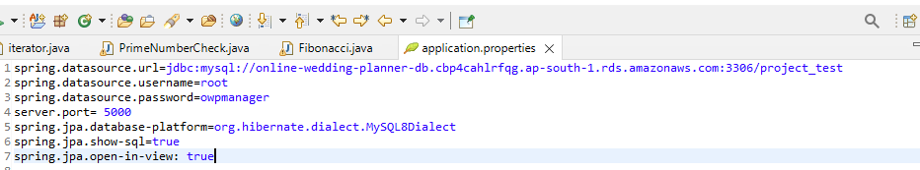

STEPS:

1.Create an application and an environment2.To create your example application, you'll use the Create a web app console wizard. It creates an Elastic Beanstalk application and launches an environment within it. An environment is the collection of AWS resources required to run your application code.3.To create an example applicationOpen the Elastic Beanstalk console using this link: https://console.aws.amazon.com/elasticbeanstalk/home#/gettingStarted?applicationName=getting-started-app4.Optionally add application tags.5.For Platform, choose a platform, and then choose Create application.6.To run the example application on AWS resources, Elastic Beanstalk takes the following actions. They take about five minutes to complete.7.Creates an Elastic Beanstalk application named getting-started-app.8.Launches an environment named GettingStartedApp -env with these AWS resources:9.Creates a new application version named Sample Application. This is the default Elastic Beanstalk example application file.10.Deploys the code for the example application to the GettingStartedApp-env environment.11.During the environment creation process, the console tracks progress and displays events.12. Elastic Beanstalk console showing the events that occur when it creates an environment 13.When all of the resources are launched and the EC2 instances running the application pass health checks, the environment's health changes to Ok. You can now use your web application's website.

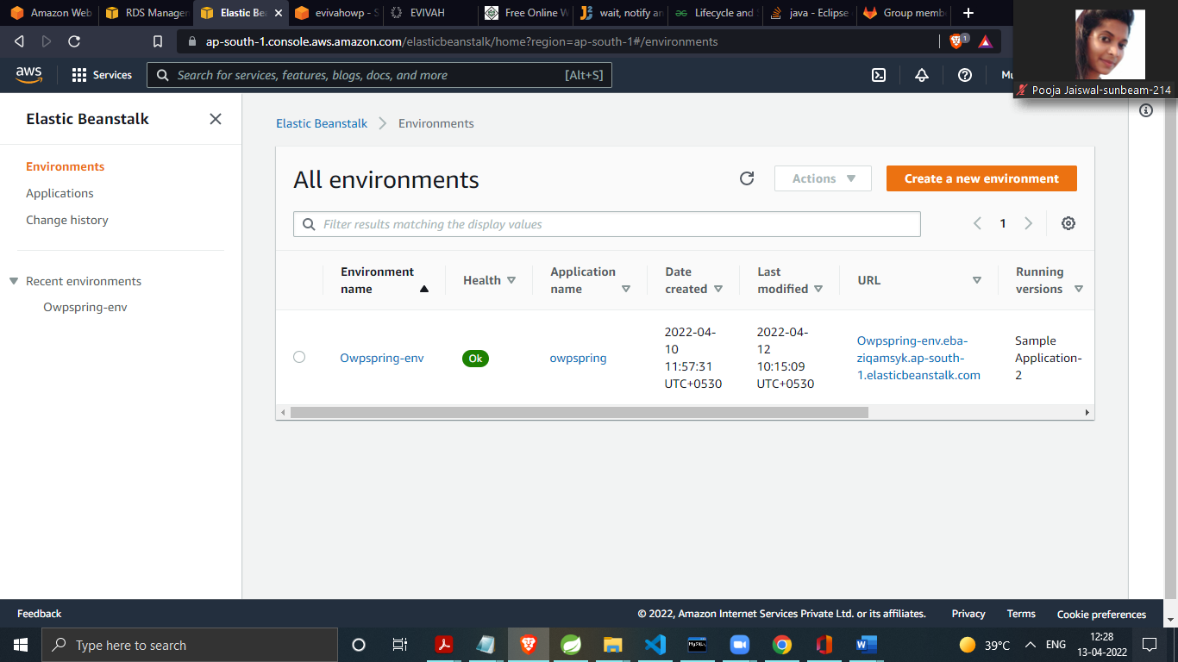

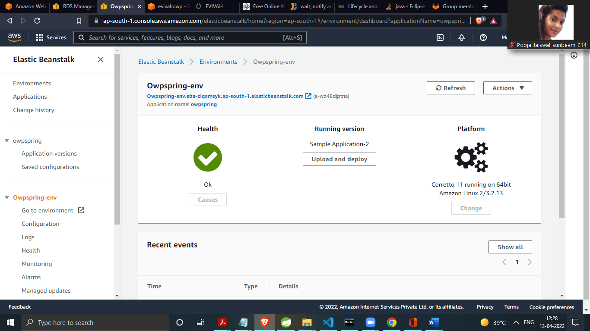

FRONTEND DEPLYMENT :

Use the elastic beanstalk url in frontend axios requests:

1. Create AWS S3 Bucket.2. Upload files from react app build folder inside this bucket.3. Set Bucket Policy to Public Access4. Enable static website hosting and upadate starting page as index.html

5.Finally the url offered by static website hosting is our deployed url.

RDS URL : online-wedding-planner-db.cbp4cahlrfqg.ap-south-1.rds.amazonaws.com

Elastic beanstalk url: <http://owpspring-env.eba-ziqamsyk.ap-south-1.elasticbeanstalk.com/>

FRONTEND URL: http://evivahowp.s3-website.ap-south-1.amazonaws.com/